Title: AI-News Monitor : Self-Healing News Topic Classification with Drift Detection & Automated Retraining

Group Members : Abhay Kashyap (B22CS001), Tejas Gupta (B22CS093)

Project Task:
Build a production-grade AI system that classifies news articles into topics while continuously monitoring model performance and detecting distribution shifts in incoming data. The platform provides a real-time API for classification and tracks prediction behavior to identify data or concept drift. If performance degrades, an automated retraining pipeline updates and redeploys the model, while a React dashboard allows users to submit articles and view predictions, confidence scores, and explanations.

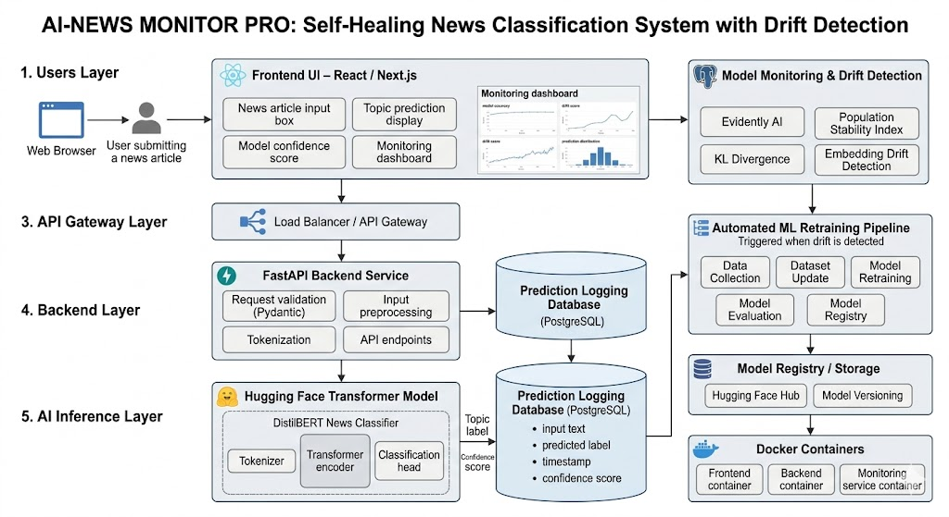

Idea Explanation:
- Modern news environments change rapidly due to technological advances, political developments, and emerging global trends.
- Machine learning models trained on historical datasets often assume future data will follow the same distribution, which is rarely true in real-world systems.
- New topics and vocabulary such as generative AI regulation, large language models, and cryptocurrency collapse continuously emerge, replacing older terms like oil price surge or trade war tensions.
- These shifts create data drift, which can significantly reduce model performance over time.
- The proposed system builds a self-monitoring ML pipeline that continuously evaluates incoming news data and detects distribution changes.
- Users interact with the platform through a React dashboard, while a FastAPI backend validates inputs using Pydantic schemas.
- Submitted text is cleaned, tokenized, and processed before being passed to a transformer-based NLP model for topic classification.
- Predictions, confidence scores, and timestamps are logged in a monitoring database for analysis.
- A monitoring service detects drift and automatically triggers model retraining and redeployment when performance degradation is detected.

Technologies & APIs:
The system is containerized using Docker and built with a React/Next.js frontend and a FastAPI backend for API endpoints, request validation, and model inference. Machine learning components use PyTorch, Hugging Face Transformers, and Scikit-learn, while data processing is handled with Pandas and NumPy. Monitoring and infrastructure include Evidently AI, SciPy, and River for drift detection, MLflow or Weights & Biases for experiment tracking, PostgreSQL for logging, Redis for caching and workflows, and AWS S3/MinIO for dataset and model storage.

Deployment Stages:
- Containerization: Docker images are created for the React frontend, FastAPI backend, model inference service, and monitoring pipeline.
- CI/CD Pipeline: Automated testing and deployment pipelines are configured using GitHub Actions or GitLab CI.
- Infrastructure Setup: System infrastructure includes load balancing, database services, object storage, and monitoring components.
- Model Initialization: When backend services start, the Hugging Face model and tokenizer are loaded into memory for fast inference.
- Monitoring Pipeline: A background service periodically analyzes prediction logs, computes drift metrics, and updates monitoring dashboards.
- Automated Retraining: If drift exceeds predefined thresholds, the system retrains the model, evaluates performance, and deploys the updated version.

Datasets and Models:
- Datasets: The primary training dataset is the AG News Dataset with four classes: World, Sports, Business, and Technology.
- Additional Datasets: Optional datasets such as the BBC News Dataset, Kaggle News Category Dataset, and HuffPost News Dataset are used for experiments and drift simulation.
- Evaluation Purpose: These datasets help test the system under different temporal data distributions.
- Primary Model: DistilBERT is used for its strong NLP performance and faster inference suitable for real-time applications.
- Advanced Model (Optional): DeBERTa-v3 is evaluated for improved contextual understanding and higher classification accuracy.
- Model Pipeline: Input text is tokenized, contextual embeddings are generated, passed through a classification head, probability scores are computed, and the predicted topic category is returned.

